**E-Commerce Customer Churn Analysis Using PowerBI**

**Objective**

The objective of this analysis is to discover customer churn rate and provide business users with insights on the impact of customers' churn, which they can use to make informed decisions and implement a personal customer retention strategy on how to improve customer retention and reduce churn rate, as well as to know the area of strengths of active customers.

**Dataset Overview**

The dataset comprises 5630 observations and 20 variables related to customer behavior and transactional details within the e-commerce platform.

**Technology Used**

* Power BI Desktop
* Power Query

## Process

1. **Data Import and Cleaning**: The data is imported into Power BI and undergoes initial transformations and cleaning using Power Query to ensure data quality and consistency.
2. **Data Modeling**: The cleaned data is modeled to create relationships between different variables and prepare it for analysis.
3. **Measures Creation with DAX**: Key performance indicators (KPIs) and measures are created using Data Analysis Expressions (DAX) to quantify customer churn and other relevant metrics.
4. **Validation**: All data transformations, relationships, and measures are thoroughly validated to ensure accuracy and reliability of insights.
5. **Dashboard Creation**: Interactive dashboards are designed using appropriate visualizations in Power BI. These dashboards provide intuitive insights into customer churn patterns, preferred order category, customer complaints, and other actionable insights.

**Visualization**

It has two dashboards Churn and Active, contains different charts bar, donut, pie, gauge , card, bookmarks etc.. we can navigate to one another through visual itself.

**Churn :** Visualization that shows ‘Customer Churn Analysis’.

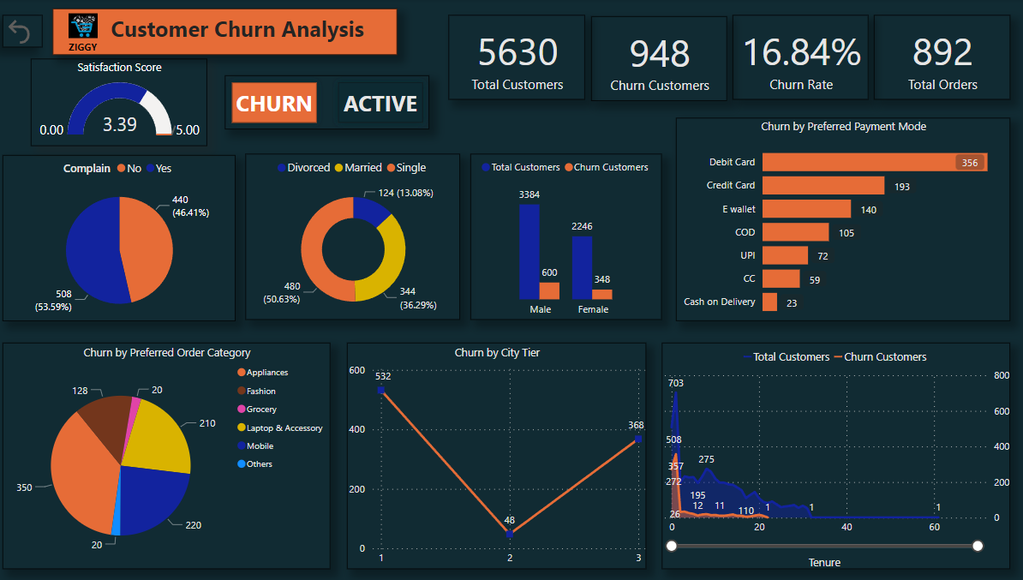

**Active:** Visualization that shows ‘Active Customer Analysis’.

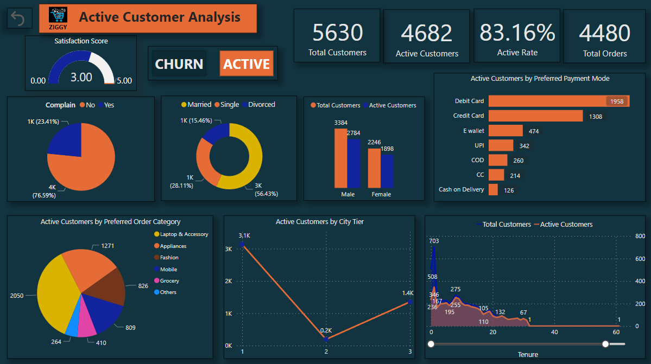

**Conclusion**

* The analysis identifies tenure, preferred payment mode, ordered category, and complaints as significant factors influencing churn rates in the e-commerce platform.
* Actionable recommendations derived from the insights include targeted retention strategies to mitigate churn and capitalize on the strengths of active customers.
* Active customers show a preference for purchasing items in the Laptop & Accessory category, exhibit fewer complaints, and are more likely to be married.

## Usage

This repository includes the Power BI files (.pbix), dataset documentation, and a detailed README to guide users through replicating the analysis and understanding the insights derived.